Lucas Swanson
11/2/2025
Programming Languages I
Reading 14
Exercise 1: Summarize
Runtime memory management is a key part of any language system and is critical when an implementation begins to utilize the heap and has many methods such as first-fit mechanisms, coalescing, quick lists, and multiple kinds of garbage collections. There is a large amount of methods to organize, clean, and maintain memory management and all have their pros and cons.
Exercise 2: Illustrate
class Main {
static int timesHonked = 0;

public static void main(String[] args) {
String x = "Ferrari";
Car myCar = new Car(x);

honk(myCar);
}

static void honk(Car thisCar){
timesHonked++;
thisCar.thisCarTimesHonked++;
String hornSound = "Honk!";

System.out.println(hornSound);
System.out.println(thisCar.thisCarTimesHonked);
}
}

class Car {
String brand;
int thisCarTimesHonked = 0;

Car(String x) {
brand = x;
}
}
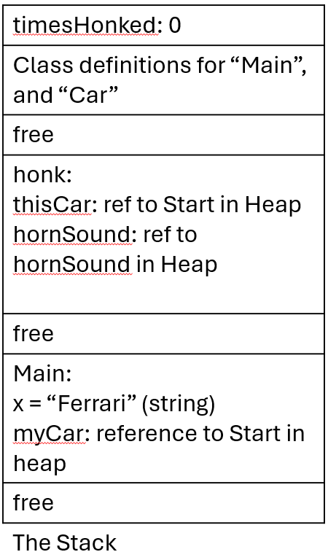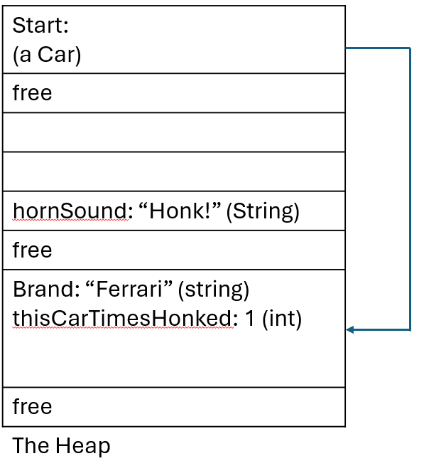
Exercise 3: Inquire
(Interview Question)
Please describe the different kind of garbage collection as well as the pros and cons of each as well as a realistic implementation they would be beneficial in.

